Rowdy Chess

Autonomous Moving Chessboard

Daniel Jones, David Newton, Mishay Naidoo

Table of Contents

Executive Summary 2

Minimum Viable Product 3

How does it work? 4

Movement 4

Detection 4

Rowdy App 4

Design 5

TestBoard Physical Arrangement 5

TestBoard Circuit Design 9

Coil Circuits 10

Sensor Circuit 11

PCB Layout 12

Project Roles 20

Milestone Breakdown 21

Project Implementation and Milestones 22

# Executive Summary

The objective of this report is to cover the creation, design and construction processes surrounding the Rowdy Chess Board. This is a chessboard that should be able to:

* Move chess pieces using an electromagnetic linear actuator array
* Detect and interpret user chess moves
* Interface, via the Rowdy App, with LiChess, the online chess platform that lets players from around the world play, practice and watch chess.

The primary objective for this report focusses on the development of the proof of concept board, or the Test Board. The Test Board will be a smaller version of the final board and will be able to prove that the overall concept will work on a smaller scale. The test board should be able to move chess pieces using the electromagnetic linear actuator array concept and receive instructions from the Rowdy App similarly to how the final board would. This board will not interface directly with LiChess because it will not be full board size. However, all the necessary concepts to prove that it will work finally will be tested in the Test Board.

Daniel Jones, David Newton and Mishay Naidoo are all involved in all processes to some degree. Each partners jobs will be detailed later in this report.

The concepts for this project have been developed throughout 2022 in informal design meetings. This project follows from a previous automated chessboard that functioned on a mechanical X-Y plotter. That project left much room for improvement.

Design for the Rowdy Board started on 19th June and will continue until 24th July. If the project is delayed due to unforeseen problems, then work will continue in November.

# Minimum Viable Product

The minimum-viable product of this project is a Test Board that can move magnetic chess pieces following instruction from the Rowdy App.

The Test Board should be able to receive instructions from the Rowdy App in the form of chess moves on a smaller scale board. It should be able to interpret these instructions and create a series of strings of bits corresponding to the instructions that will activate electromagnetic coils to move a magnet in a predefined manner.

The Test Board should also be able to detect a user chess move. The board, using magnetic Hall sensors, must be able to detect when a magnet has been removed from a chess square and when it is placed on another square, signalling a chess move has taken place. This should then be sent to the Rowdy App as a confirmation that a move has taken place.

The Rowdy Test App should be able to facilitate all of these processes by interfacing with the user and the Test Board.

# How does it work?

The Rowdy Test Board operations have been divided up into categories that will interface with one another. The categories are as follows:

* Movement
  + Coil design
  + Control
  + Pathing
* Detection
  + Sensor design
  + Control
* Rowdy App
  + User interface
  + Board integration
  + Processing

## Movement

The entire Rowdy Chess Board will be created on a printed circuit board. The movement of chess pieces will be facilitated by an array of electromagnets that will turn on and off sequentially, causing movement of chess pieces with magnets on the board. These electromagnets are PCB coils, spirals of trace on the PCB. The spiralling current will act as an electromagnet that will be turned on and off by a microcontroller.

The coils are activated by mosfets that either ground or power the coils. These mosfets are connected to shift registers that receive serial data from a microcontroller. Multiple coils will need to be turned on during movement of a piece. Due to the nature of the wiring of the coils, multiple coils cannot be turned on at the same time, so they will be switched on and off sequentially to make the coils seem like they are all on at the same time. This will be necessary when pathing a piece from its start to end location.

## Detection

Amongst the PCB coils, Hall sensors will be strategically placed in order to detect the position of the magnets in the chess pieces on the board. Hall sensors are small electronic devices that can output high/low voltages depending on the strength of the magnetic field present. These Hall sensors are connected to a shift register that will output a constant serial stream to a microcontroller. This can then determine which hall sensors have been triggered and therefore, which squares are occupied by chess pieces.

## Rowdy App

For the Test Board, the Rowdy App will only need to interface with the user and the board. The app will be able to send instructions to a microcontroller that will then send data to the Test Board. The app will taker user input, in the form of pseudo chess moves, and ultimately activate movement on the chess board.

# Design

## TestBoard Physical Arrangement

The design of the Rowdy Test Board has been through multiple design iterations. First we will walk through some initial, basic design decisions.

The idea is to have a chess piece move from one square to another by switching on a coil close to the chess piece.

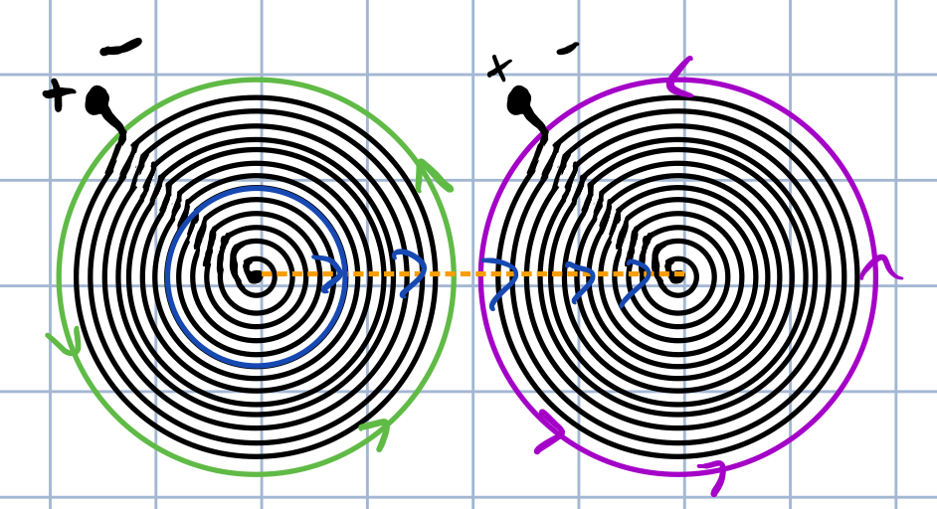

Unfortunately, we cannot simply have one coil per square, as the knights need to move between pieces, along the seams of the squares. And so some design decisions needed to be taken around arrangement of coils.

Here are some design ideas: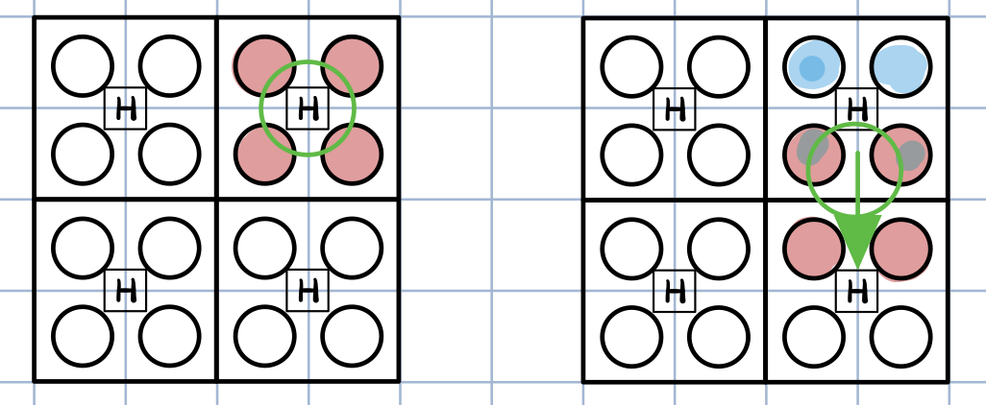

This design would have multiple coils on in order to hold a piece in place. It unfortunately relies on every coil having the same strength, and exact placement from the user, which is not practical.

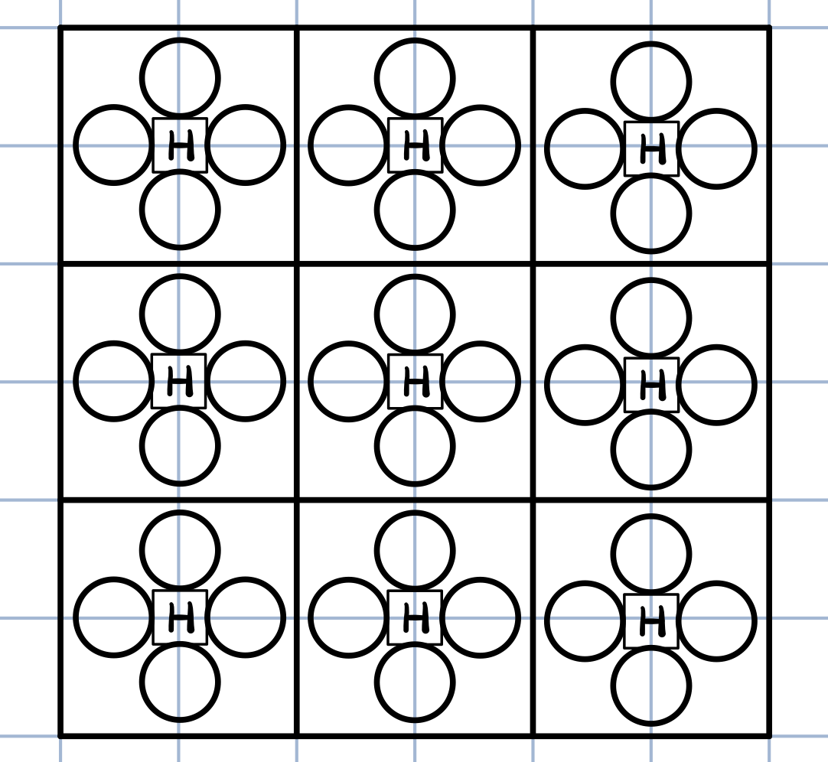

The same problem exists in this design.

The decision was then taken to try and put coils on the seams:

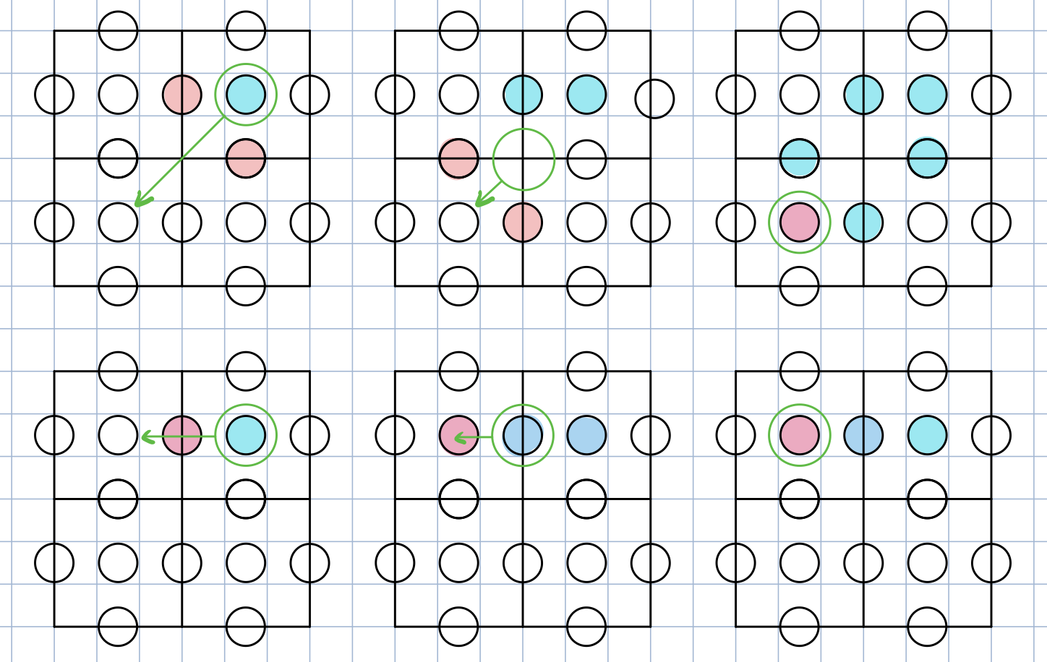

How the pieces would move diagonally and horizontally is also depicted here. But again, in order to move a piece diagonally, multiple coils need to be on. And so eventually, the final arrangement of coils arrived:

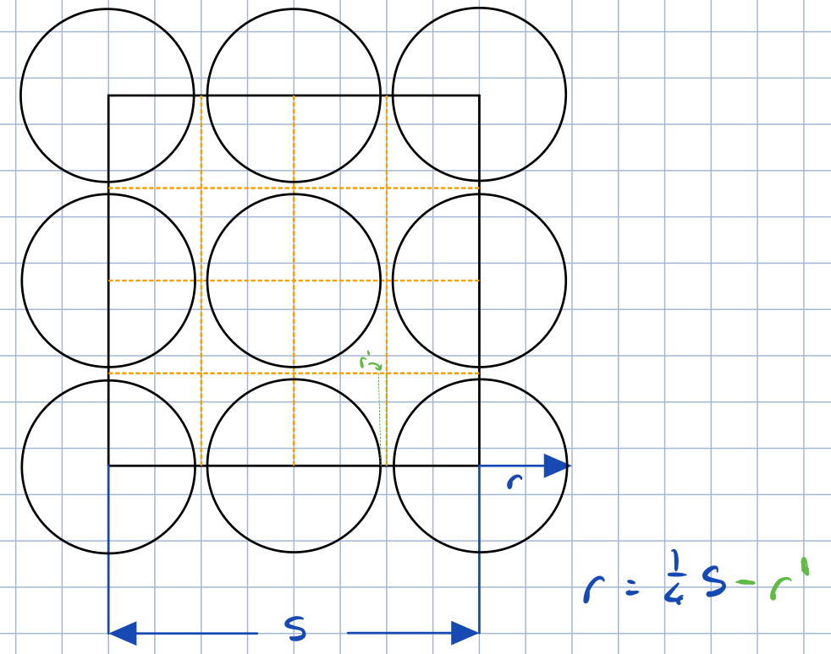

Each square will have 9 coils, with adjacent squares sharing 3 coils along their seams.

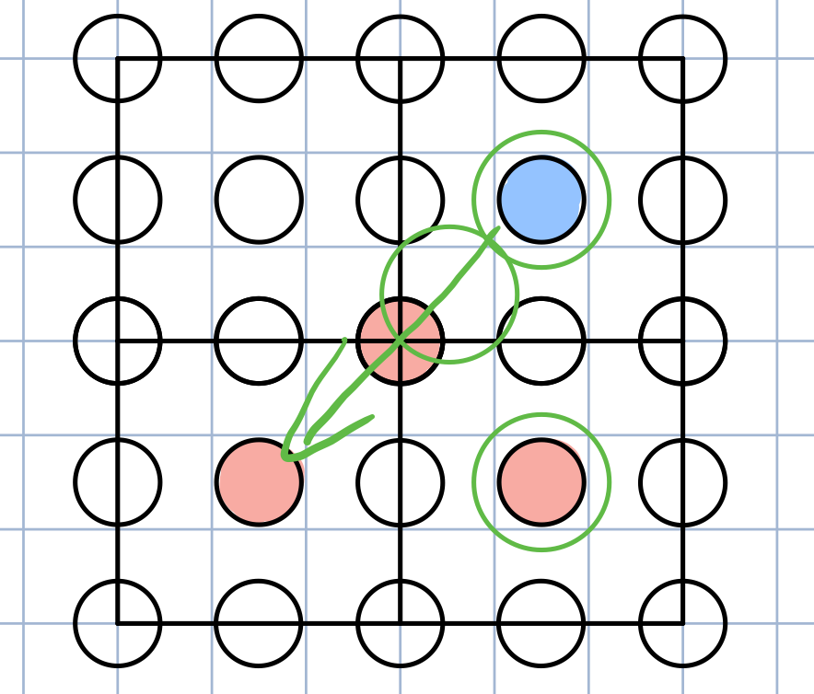

A spiral of trace will exist on each layer of the board. After doing research on other projects with PCB coils and taking costing into account, a decision was made to make a 4-layer board with 3-layer coils.

The initial design idea was to create one 500mmx500mm PCB that would contain the entire chessboard. However, 4-layer PCBs that are 500mmx500mm could cost over 300 dollars. Instead, the decision was taken to create a much cheaper repeatable unit board that is 100mmx100mm. This design needs to be able to connect together like puzzle pieces to make up an entire board. Each of these pieces also needed to be accessible by a microcontroller to send and receive data. This is a dramatically cheaper decision.

The problem with arranging the puzzle piece board as above is that the coils cannot connect across boards. So the actual PCB needs to be offset from the chess board squares. They will be known as the TestBoard and PseudoBoard from here on.

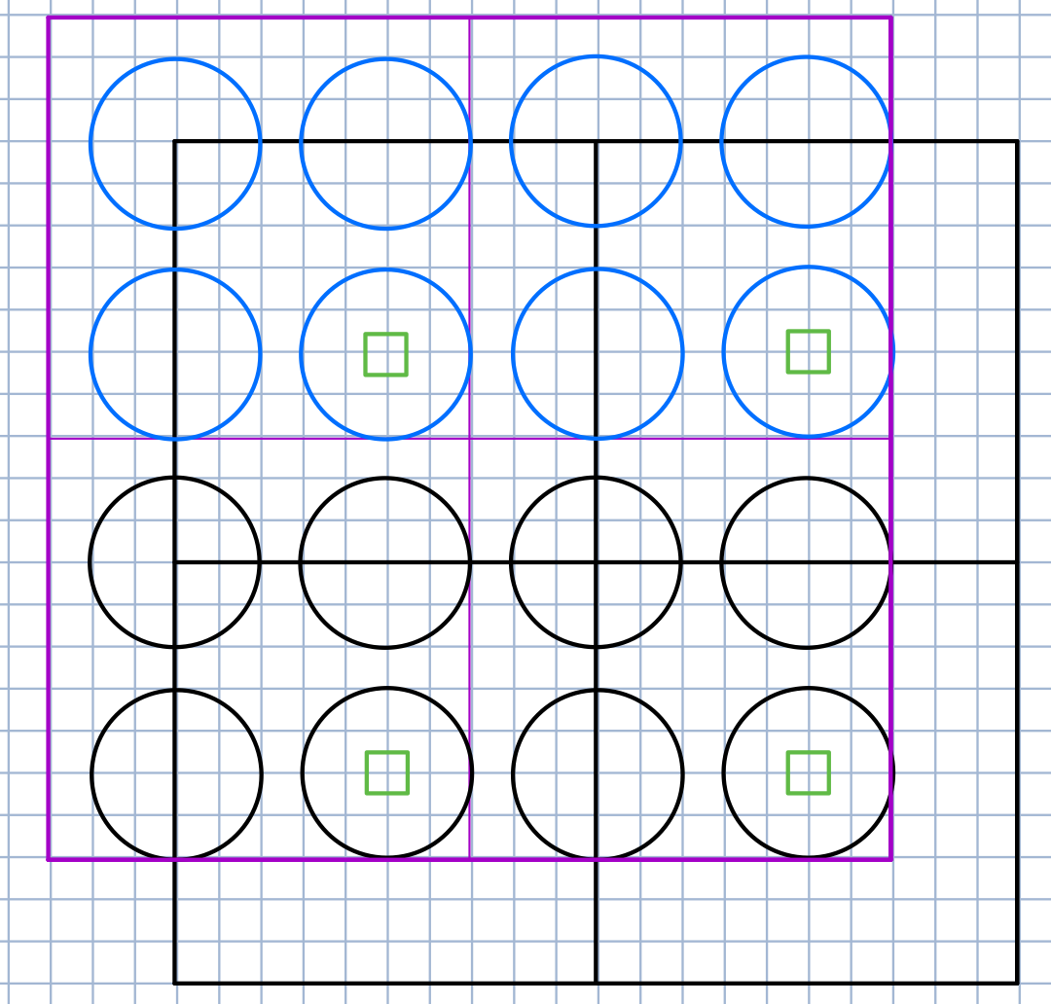

The purple outline depicts the TestBoard and the black lines depict the squares of the PseudoBoard. The circles represent the coils and the green squares are the hall sensors.

This puzzle will fit together like this:

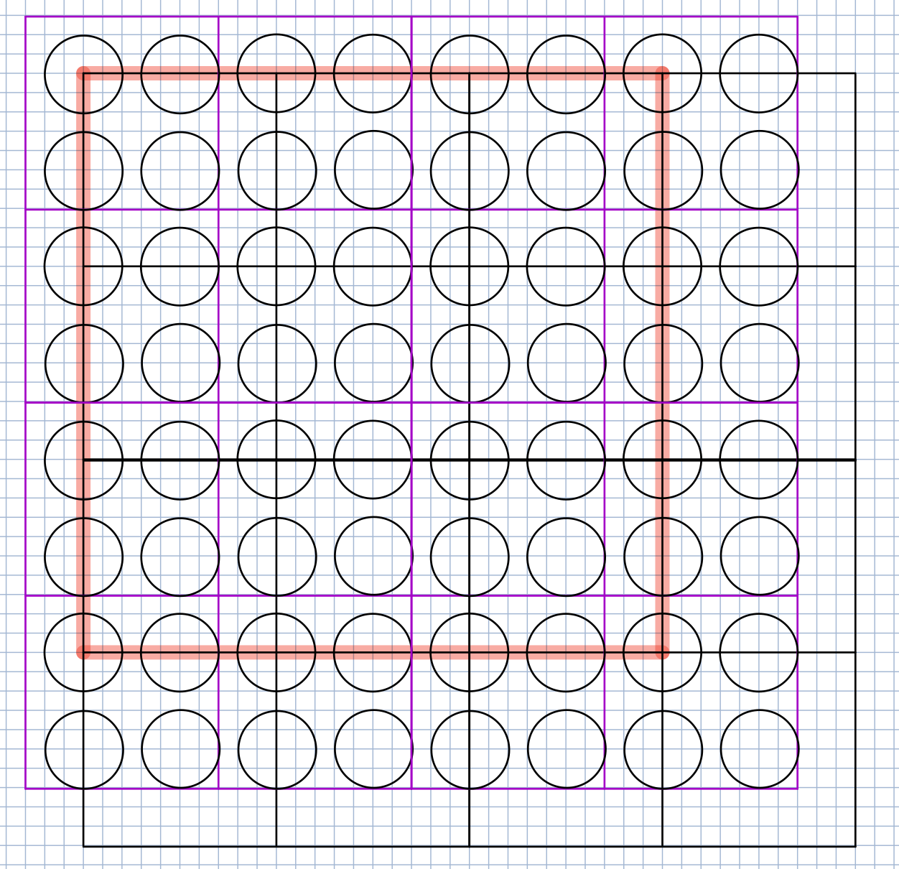

This is four TestBoards put together to create a testable 9x9 chessboard. The Final design will use 36 TestBoards like this:

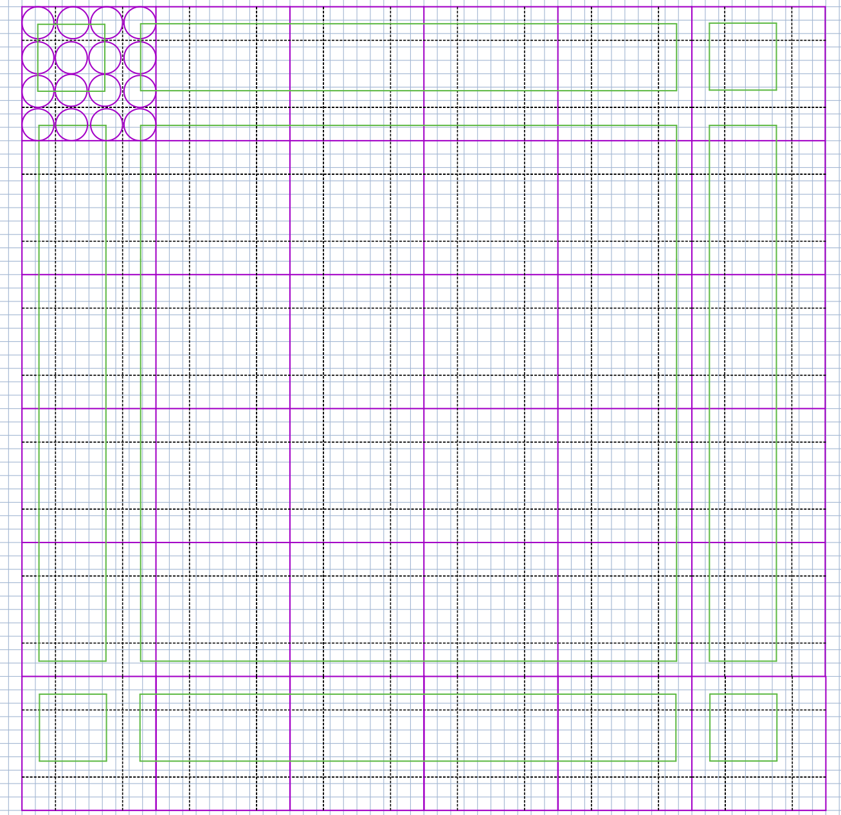

## TestBoard Circuit Design

It is not feasible for each coil to be controlled by a GPIO pin through a mosfet of a microcontroller. This, for the final board, would require 576 GPIO pins just to control the coils and 100 pins for the Hall sensors. And so a better method needs to be developed to control the board.

### Coil Circuits

In order to manage many coils, with a few GPIO pins, we first need multiple switches for each coil:

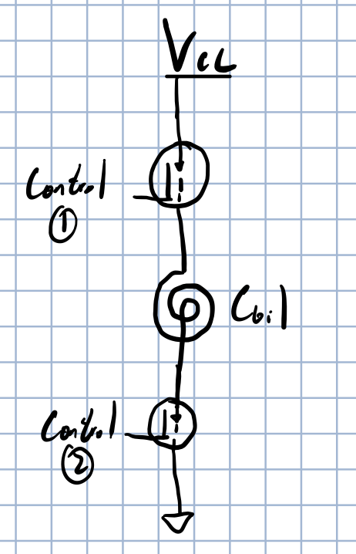

Here, one mosfet is turned on to power the coil, and another mosfet is used to ground the coil. This means that the coil will only turn on if both mosftes have been switched on. Now, if we think of a mosfet as controlling power to a row of coils, or controlling grounding to a column of coils, we can set up a grid as follows:

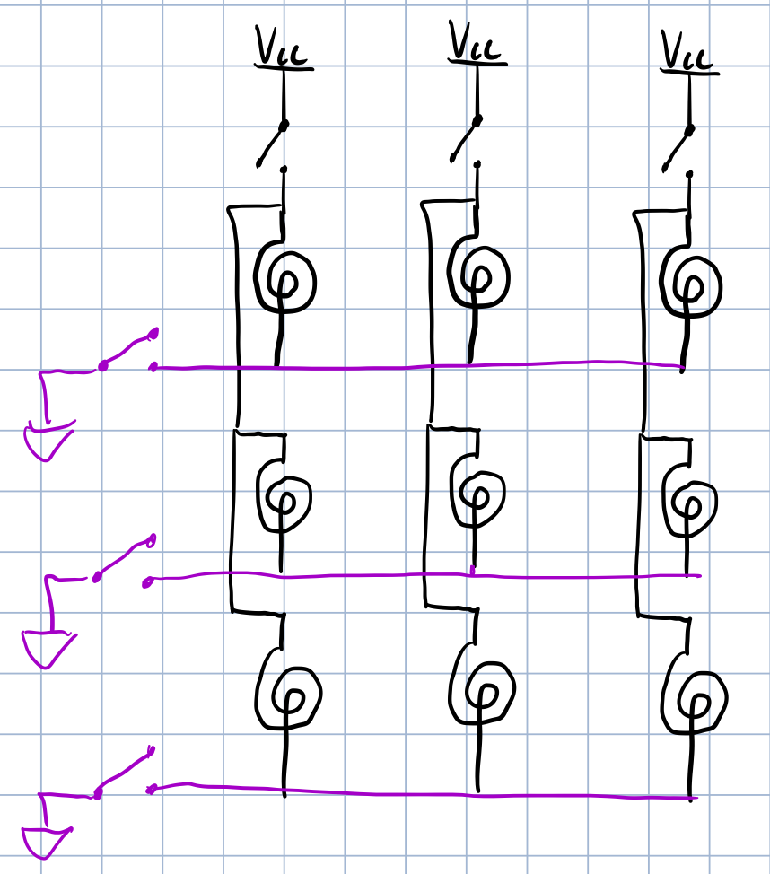

So we can control many coils with only a few mosfets. In order to turn on the centre coil above, we only need to close the second Vcc switch and the second grounding switch. But we still need to access quite a few mosfets, and so another decision needs to be made so as to decrease the number of GPIO pins needed. We could use multiplexers, but for our purposes, series to parallel switch registers will work best. We should be able to output a bit stream from the microcontroller to the switch register which will output values based on the bit stream.

This is what the circuit schematic looks like this far:

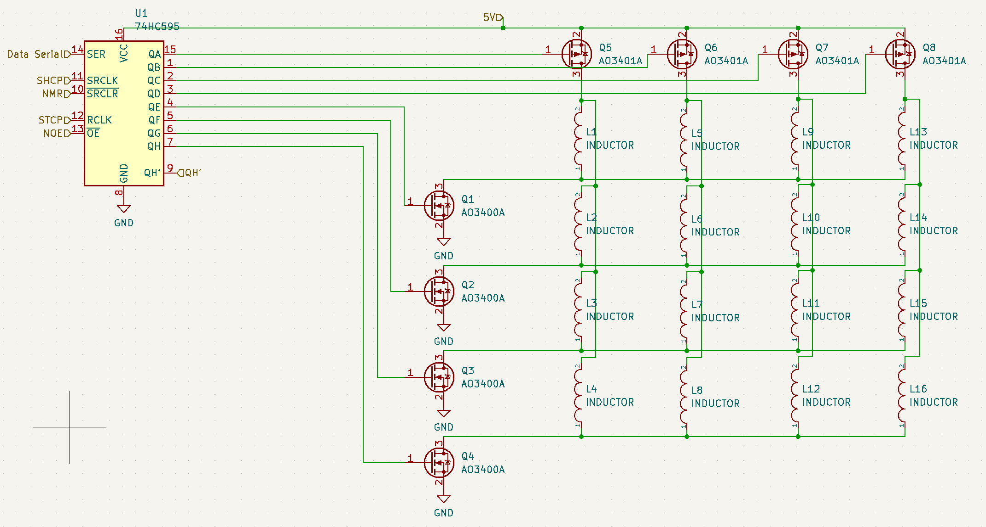

The decision was now taken to add in greater functionality to the TestBoard. We would like to be able to reverse the polarity of a coil to create a pushing force on the magnet above. This is to try and increase the force pulling a moving magnet from one square to another. And so this is what the final schematic looks like:

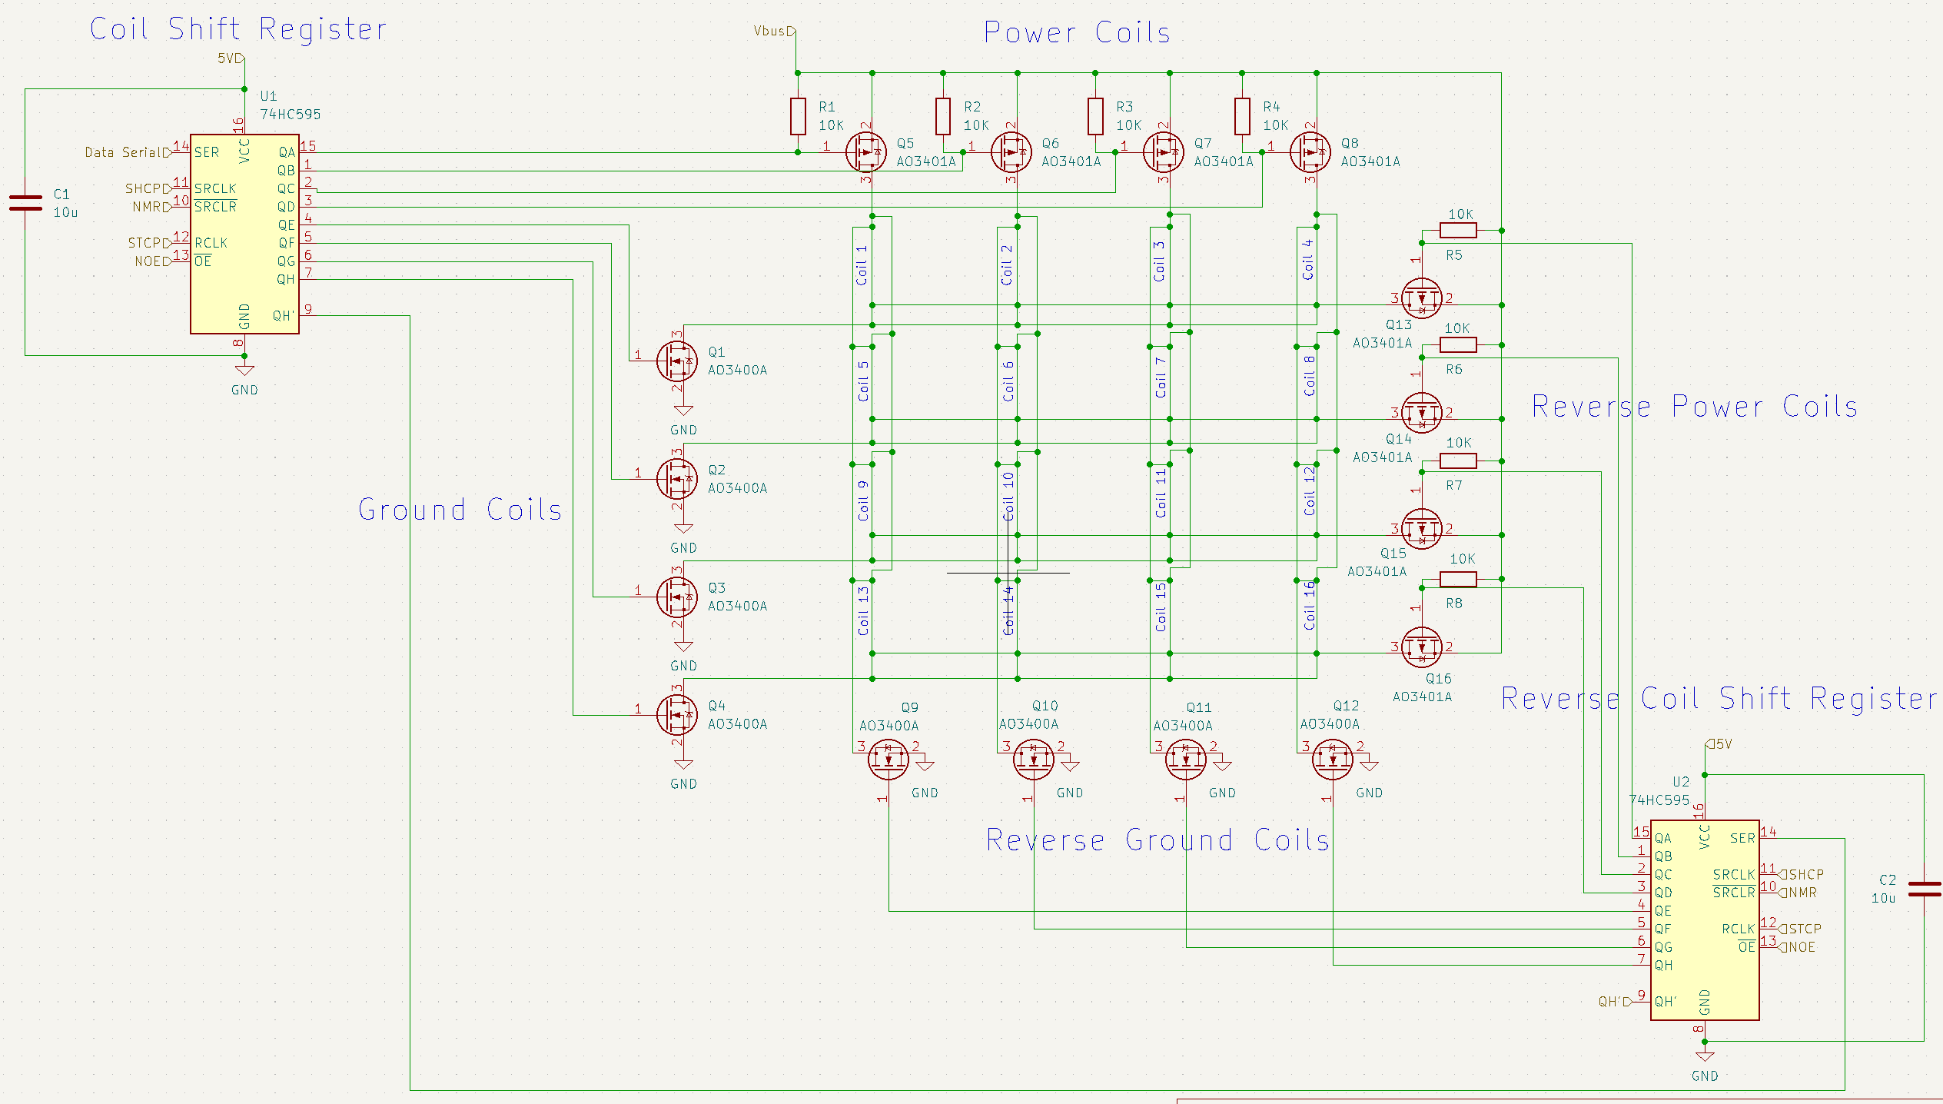

### Sensor Circuit

The Hall Sensors will be placed at the centre of each square on the bottom layer of the PCB. They will transmit their data through a parallel to series switch register. This is the circuit schematic:

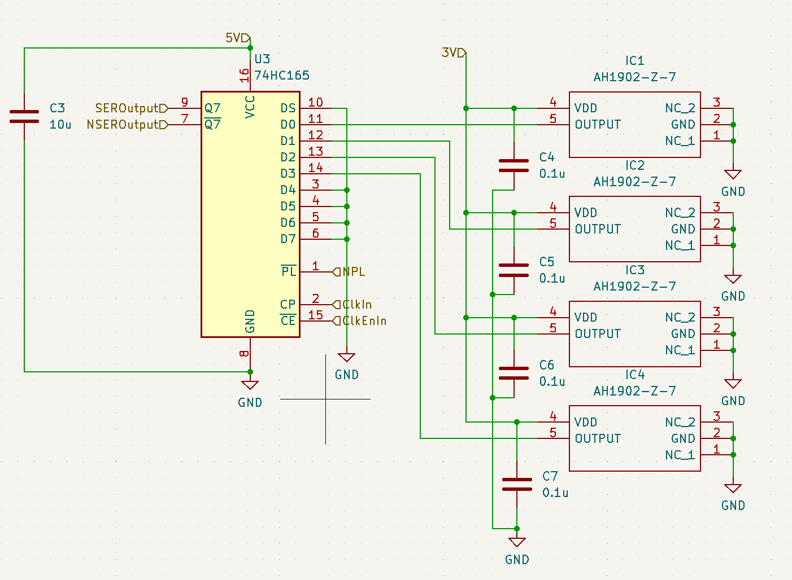

### PCB Layout

The basic 4 layers will look like this:

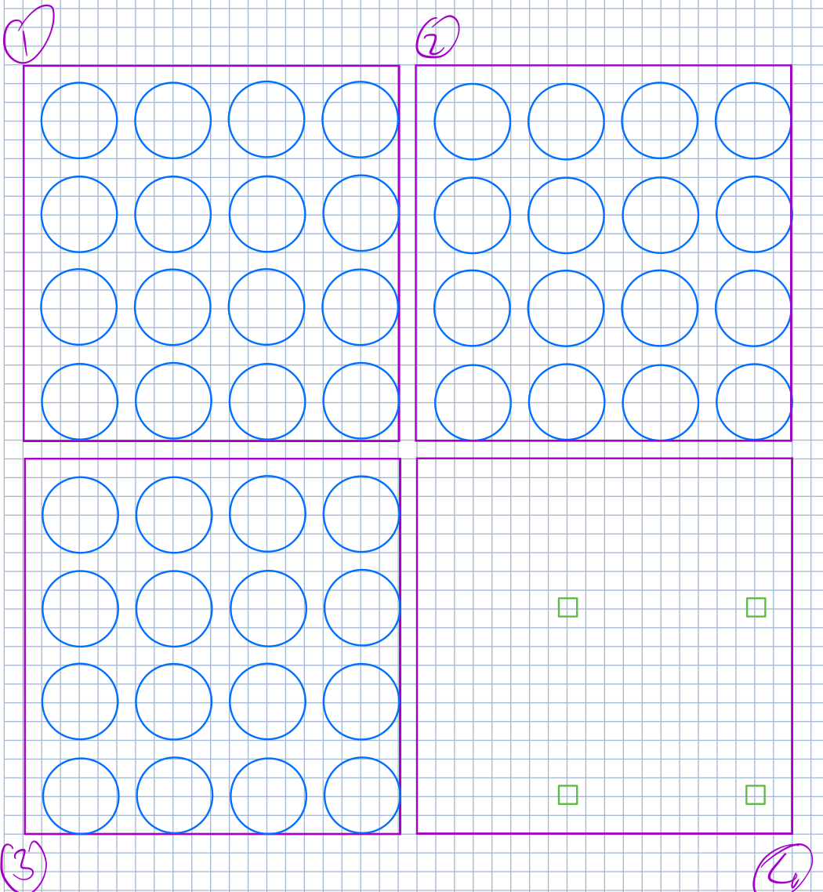

This just displays the coils and hall sensors on each of the 4 layers. It does not include all the pin headers and switch registers.

The following is the layout of the PCB, layer by layer:

Layer 1:

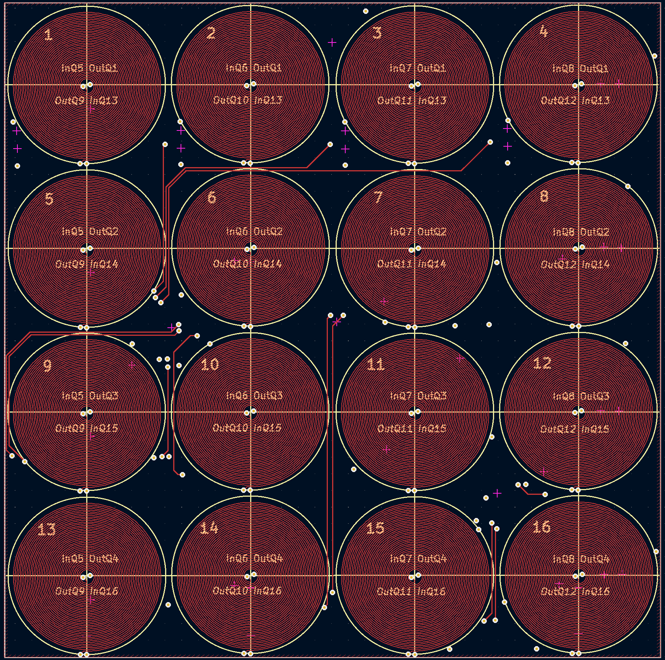

Layer 2:

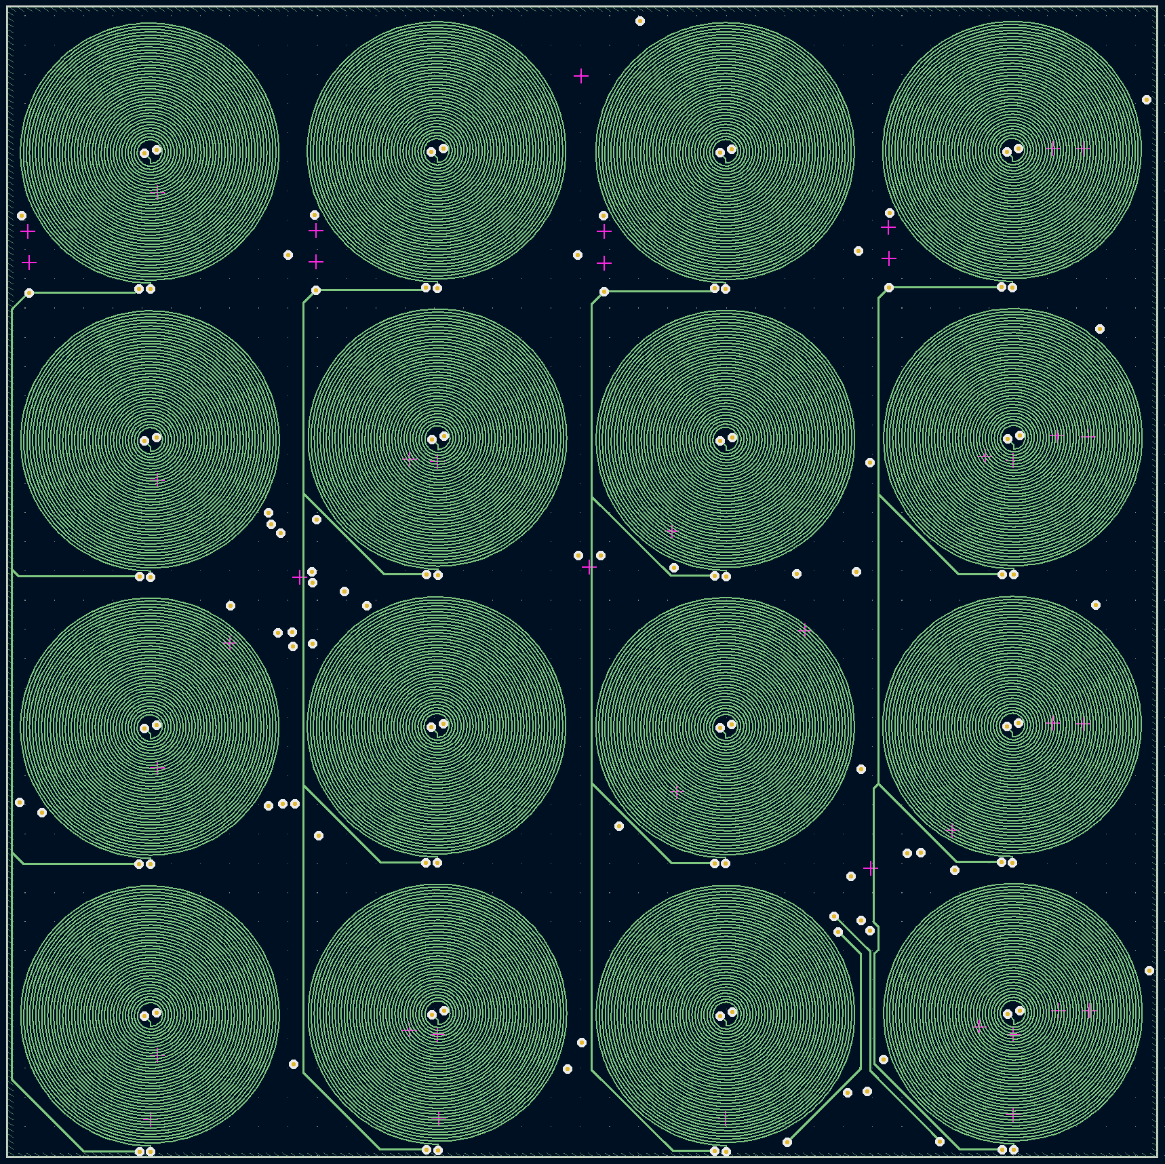

Layer 3:

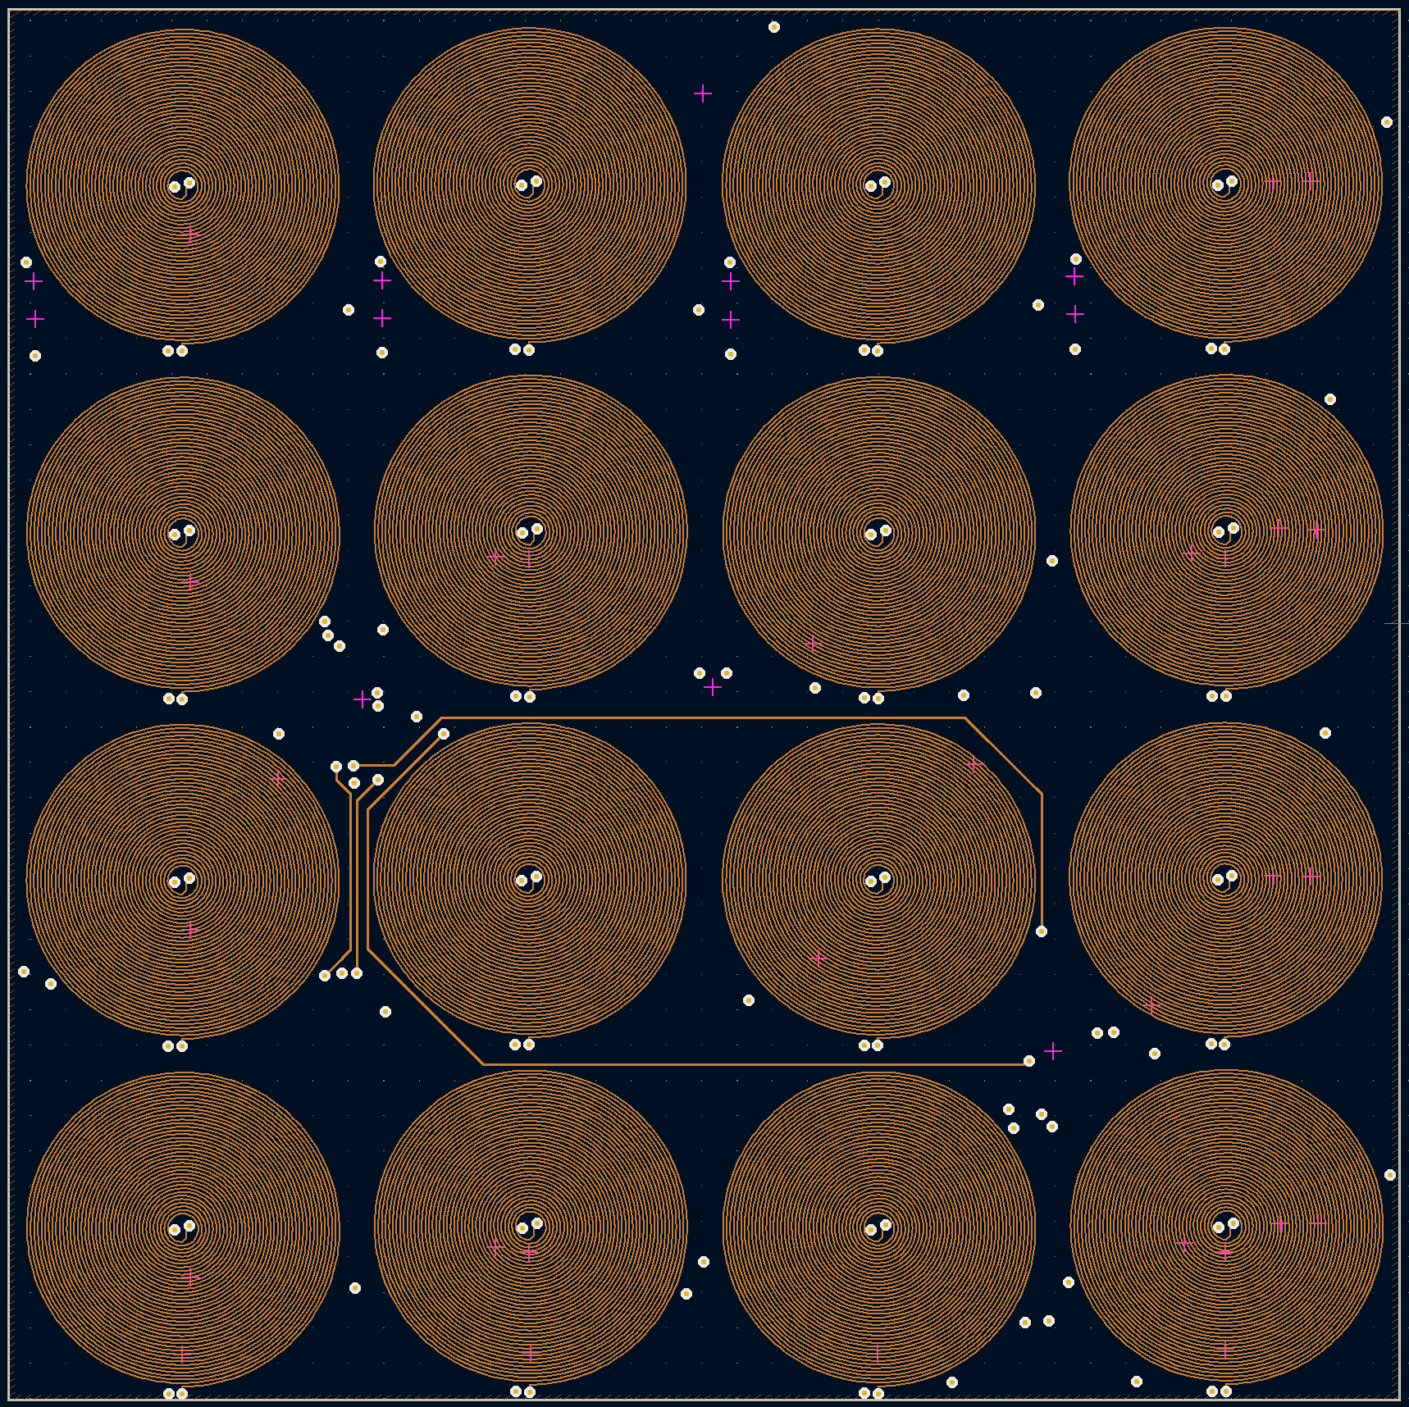

Layer 4:

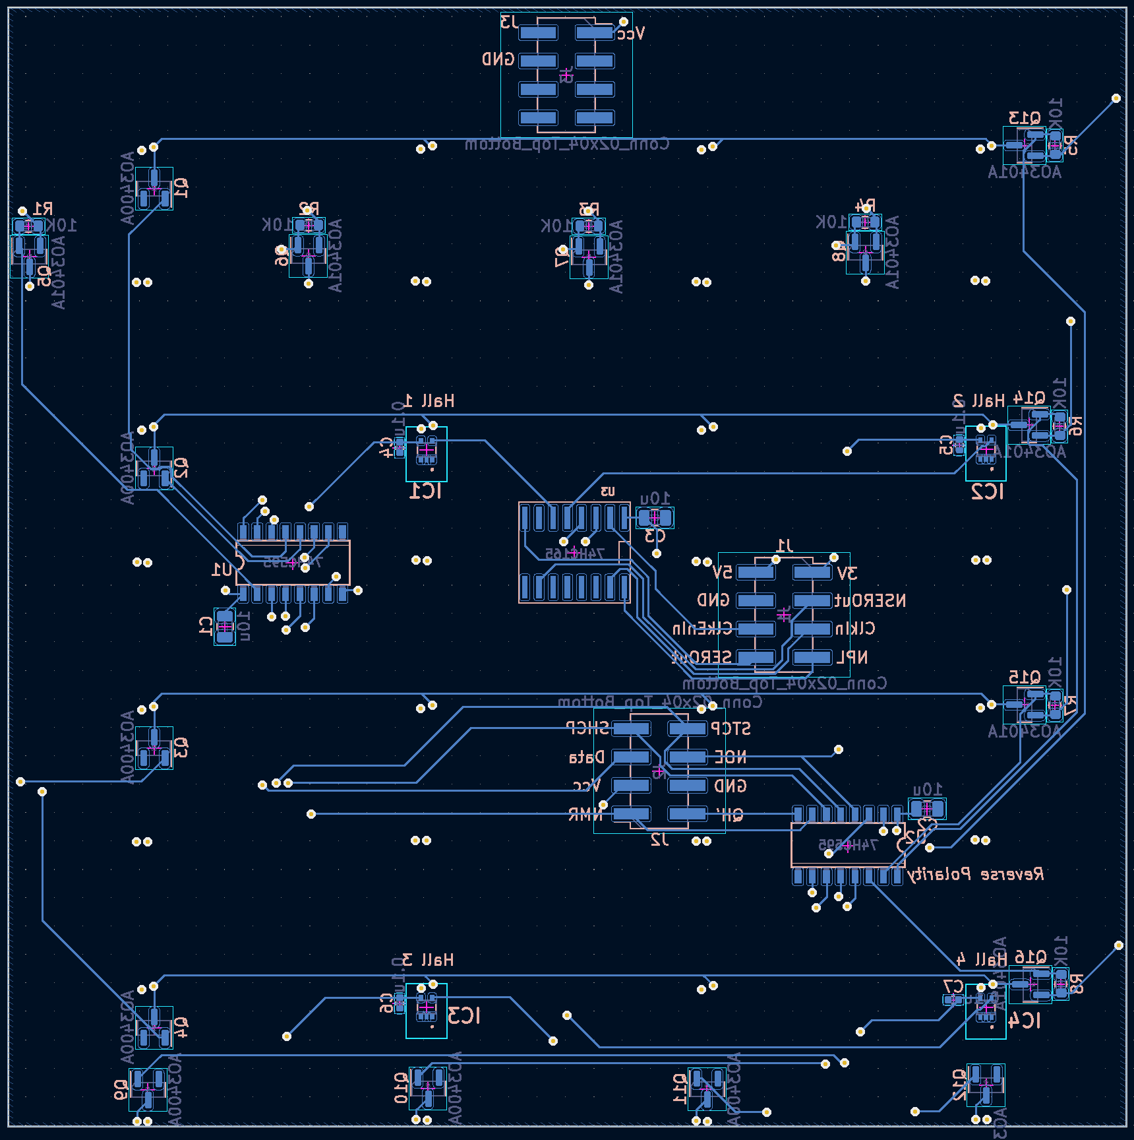

The layout altogether:

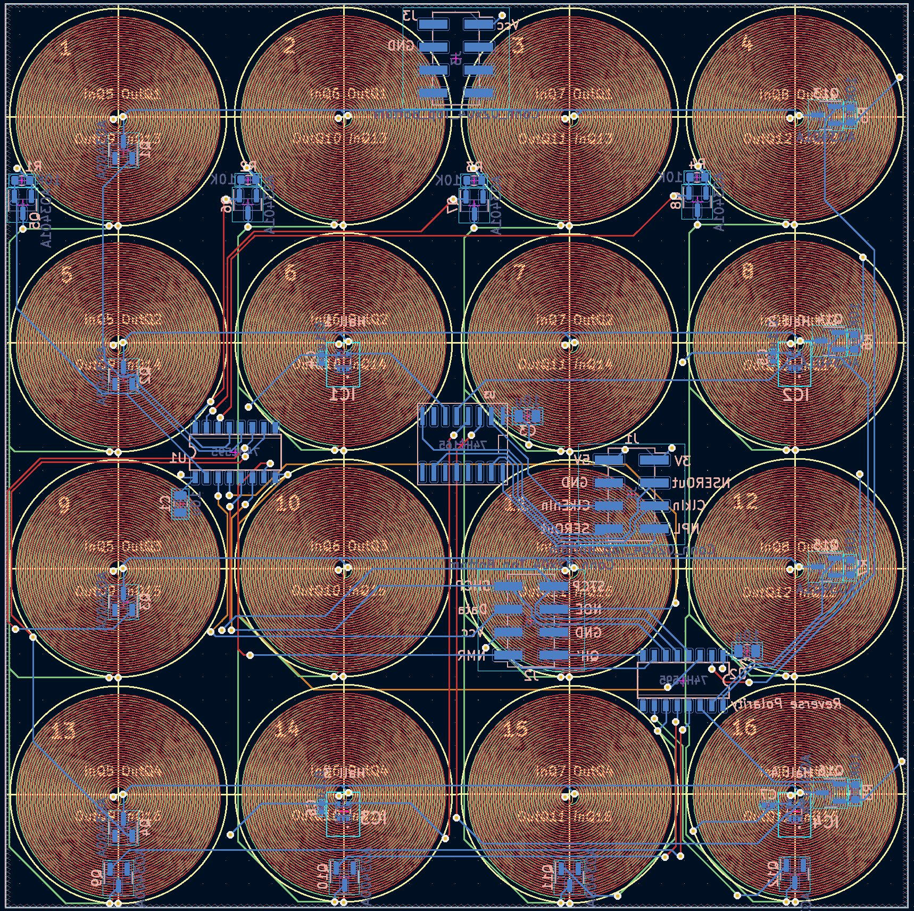

And a 3D of front:

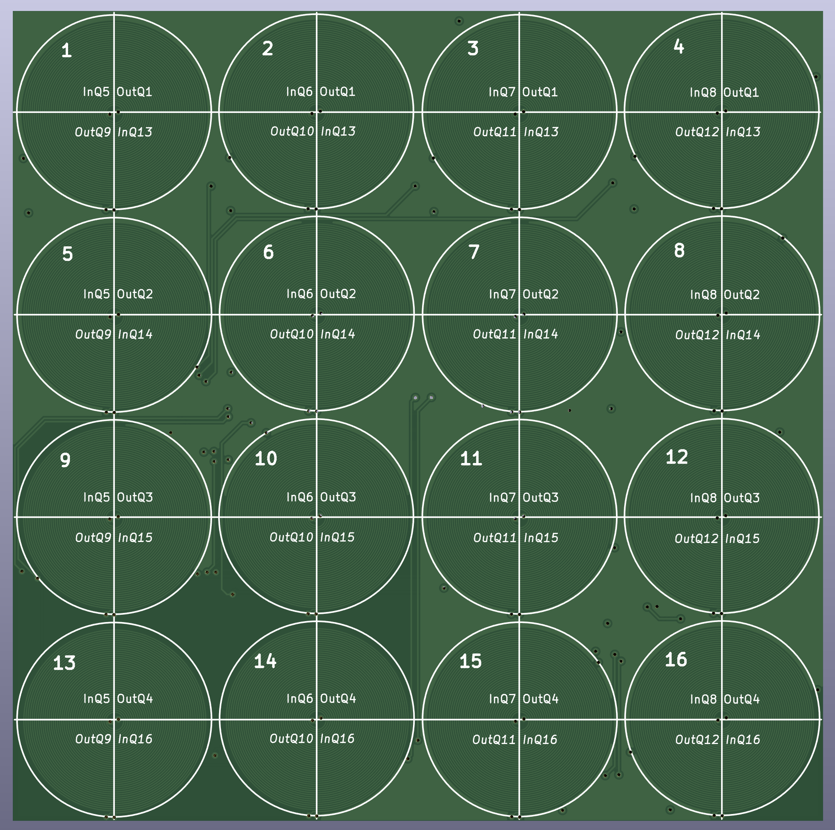

3D view of the back:

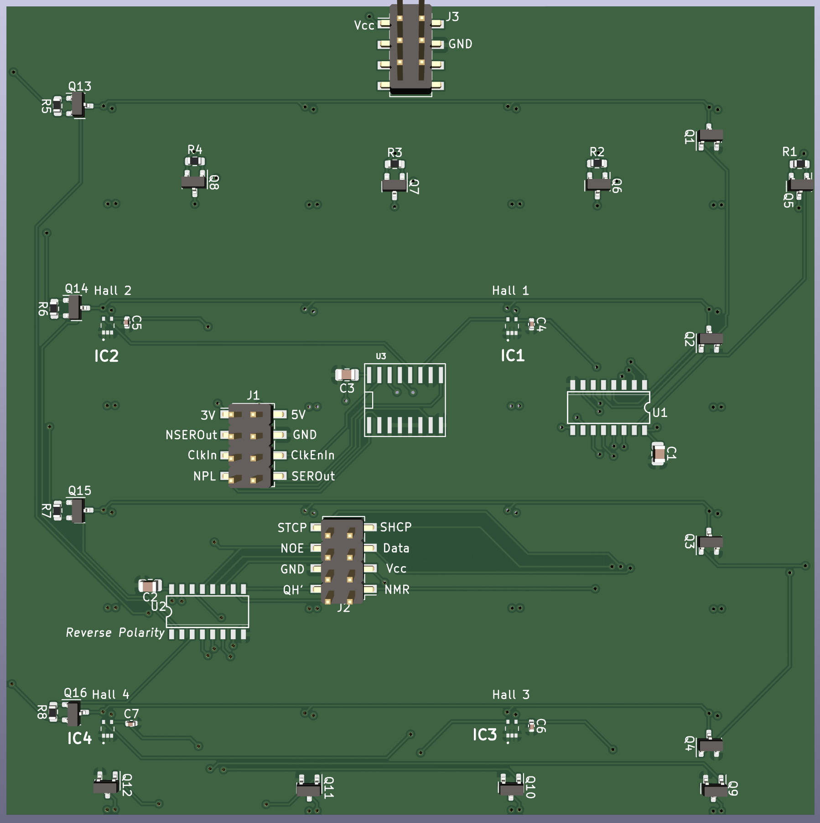

# Project Roles

|  |  |  |
| --- | --- | --- |
| **Daniel** | **Tasks** | **Description** |

|  |  |  |
| --- | --- | --- |
| **David** | **Tasks** | **Description** |

|  |  |  |
| --- | --- | --- |
| **Mishay** | **Tasks** | **Description** |

# Milestone Breakdown

|  |  |  |  |
| --- | --- | --- | --- |
| Task | Description | Completion Date | Team Member |
|  |  |  |  |
|  |  |  |  |
|  |  |  |  |
|  | This is a changing document where more milestones will be defined. |  |  |

# Project Implementation and Milestones